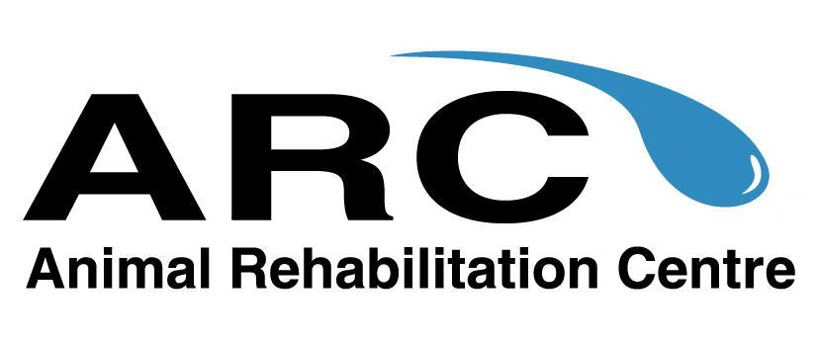
Animal Rehabilitation Centre
920 Yonge Street, Suite #115, Toronto, Ontario M4W 3C7
tel: 416.964.9346 fax: 416.964.2443
email: info@animalrehabcentre.com
www.animalrehabilitationcentre.com

Veterinary Referral/Consent form

Patient Name:
_____________________________________________________________________________

Owner Name:
______________________________________________________________________________

Reason for referral for rehabilitative services:
______________________________________________________________________________

______________________________________________________________________________

Any other medical conditions/concerns that we should be aware of:
______________________________________________________________________________

______________________________________________________________________________

Referring DVM name:
______________________________________________________________________________

Referring Veterinary Clinic:
______________________________________________________________________________

This document confirms that the above noted veterinarian consents to rehabilitation services at the Animal Rehabilitation Centre. All therapies will be performed by Certified Canine Rehabilitation Practitioners.

Referring Veterinarian Signature:

__________________________________

Date:

__________________________________

